PARCENOMICS
aggregate · assimilate · evaluate
Locked Twice

Solving the Massachusetts PILOT Problem

Article 97 keeps rural Massachusetts land off the tax rolls and out of the housing pipeline. The PILOT Commission can fix only one of those. It should recommend fixing both.
A Parcenomics whitepaper — submitted for the record of the Governor's PILOT Commission, Executive Order 645
Patrick White · Principal Researcher, Parcenomics
www.parcenomics.com · patrickwhitestockbridge@gmail.com · 413-441-5231
Draft — July 2026 · © 2026 Patrick White · Free to quote and share with attribution

The proposition, stated first
Most of what the Commission will hear this summer is an argument about how to divide $54.5 million. This paper makes that argument too, because the division is genuinely inequitable — fewer than one acre in five draws more than half the money.
But the Commission should know at the outset that the argument has a ceiling, and the ceiling is low. The Department of Revenue's own estimate puts the entire aggregate shortfall at $4.5–5.5 million. Every dollar could be appropriated tomorrow and the disparity would remain, because a proportional increase applied to a disproportionate base preserves the disproportion exactly.
So this paper's principal recommendation is not about the formula at all.
Massachusetts holds roughly 461,000 acres of PILOT-eligible land, much of it in towns with almost no other path to tax base growth. Some fraction of the perimeter of that land is already-disturbed ground fronting existing public roads — old field edges, former landings, roadside strips, parcels acquired incidentally as part of larger tracts. None of it is ecological core.
Releasing a screened portion of that edge for housing would convert untaxed acreage into permanent municipal tax base, produce housing in the communities least able to zone their way to it, strengthen rather than weaken core conservation, and cost the Commonwealth nothing.
Four things make this work, and all four already exist:
- Proposition 2½ makes it permanent. New growth is added to the levy limit and stays there. A PILOT dollar is an appropriation subject to next year's politics; a converted acre is capacity the town owns outright and compounds on.
- BioMap already draws the line. The Natural Heritage program's Core Habitat and Critical Natural Landscape layers, with connectivity modeling, exist and are currently linked to no disposal pathway at all.
- The conservation literature already sets the buffer. The Environmental Law Institute's synthesis of more than 1,400 studies recommends 230–300 meters from habitat edges.
- Other states already run the swap. New York has amended its constitution roughly sixteen times to execute equal-or-greater-value Forest Preserve exchanges. Every one ran net-additive to conservation.
No state has assembled these into a single pathway. The pieces sit in New York, Maine, New Jersey, Florida, and Massachusetts, unconnected. The Commission has the opportunity to recommend a first-in-nation framework in which edge release funds core consolidation — peripheral acres out, higher-value core acres in, under the existing Article 97 two-thirds vote and the Public Lands Preservation Act's no-net-loss test.
The obstacle is not cost, and it is not ecology. It is that Article 97 currently does double duty against the very communities this Commission was convened to examine — holding their land off the tax rolls, and simultaneously holding it out of the Commonwealth's flagship land-for-housing program.
That argument is developed in Part IV. Everything before it establishes why the alternative is insufficient.

Summary
The Commission has been asked whether the PILOT program for State-Owned Land works as intended, how it affects municipalities, and whether it balances the Commonwealth's conservation, biodiversity, and climate goals.
This paper answers that the program works exactly as designed, that its design compensates land value and nothing else, and that the resulting geography is severe: four western counties host 55.4% of the Commonwealth's eligible state-owned acres and receive 18.9% of the dollars. Berkshire County alone holds 29.2% of the acres and receives 8.4% of the money.
But the paper's central argument is not about redistribution, and the Commission should be skeptical of anyone who tells it the answer is a larger appropriation.
The aggregate gap is small. The Department of Revenue's own estimate is that running the program at local tax rates would cost $59–60 million against an FY2026 actual of $54,508,272. That is a shortfall of roughly $4.5–5.5 million — eight to ten percent of the program, and six one-hundredths of one percent of the $8.1 billion in FY2026 local aid. Every dollar of it could be appropriated tomorrow and the geographic disparity would remain, because a proportional increase applied to a disproportionate base preserves the disproportion exactly.
Massachusetts is also not stingy — but the aggregate conceals more than it reveals. On a blended basis the Commonwealth pays about $117 per acre. That figure averages 178 acres of Boston land at $5,642/acre with 135,417 acres of Berkshire forest at $34/acre, and describes neither.
Disaggregated by land class, the program's actual behavior appears:
Seven high-value counties hold 17.8% of the Commonwealth's eligible acres and receive 54.5% of the dollars, at $359 per acre. Seven large-tract counties hold 82.2% of the acres and receive 45.5%, at $65 per acre. Berkshire and Franklin — the two counties with the largest undeveloped holdings — receive $34 and $33 per acre respectively.
This is the disparity host communities actually experience, and it is a land-class problem before it is a regional one. The formula pays in proportion to land value and applies a single uniform rate to every acre in the Commonwealth. Value-proportionality is a defensible basis for compensating a developed parcel in a city. It is the wrong basis for a twenty-thousand-acre forest, because the burden that forest imposes on its host town does not scale with its assessed value.
Even so, the Commission should be careful with cross-state comparisons. Measured like-for-like against comparable land, Massachusetts still pays more than the states most often held up as models: Berkshire's $34 per acre against Minnesota's $5.281 acquired-natural-resources floor is roughly six times higher. Any recommendation framed as "pay more, the way other states do" will not survive contact with the numbers.
What those states do differently is not pay more. It is classify. Minnesota sets distinct rates by land category — a flat $3.087 per acre for tax-forfeited and other Department of Natural Resources land, and the greater of $5.281 per acre or 0.75% of appraised value for acquired natural resources land. Wisconsin, Michigan, and Pennsylvania likewise use per-acre bases for undeveloped holdings. Massachusetts uses one value-proportional rate for everything it owns.
The real finding is structural, and it connects two problems the Commonwealth currently treats as unrelated.
Article 97 of the Amendments to the Massachusetts Constitution does double duty against rural host communities. It holds conservation land off the local tax rolls, which the PILOT program partially and unevenly compensates. And it holds that same land out of the Commonwealth's flagship land-for-housing program: the Affordable Homes Act §122 guidance is explicit that eligible surplus land is all state-owned land not subject to Article 97. State Land for Homes has advanced roughly 700 acres toward 5,600+ housing units — courthouses, parking lots, a former group home, a university campus. Institutional surplus, concentrated where the institutions are, which is east.
So the counties holding 55.4% of the eligible acres are structurally excluded from the state's principal mechanism for converting public land into taxable housing, by the same constitutional provision that makes their land untaxable in the first place.
That is the connective tissue, and it points to a reform the Commission has not been asked to consider.
This paper therefore proposes two independent tracks, not a sequence.
Track A fixes the formula. It is bounded — the entire prize is $4.5–5.5 million, it is zero-sum among municipalities, and it requires legislation or appropriation.
Track B grows the base. It is unbounded, positive-sum, permanent under Proposition 2½, and it takes nothing from any other community. Its core is a screened edge-release program: peripheral, already-disturbed conservation land adjacent to existing roads, released for housing under ecological screening, with proceeds and land swaps directed to consolidating ecological cores.
Track B is the more important of the two, and it is the one no state has built. The Commission has the opportunity to recommend a first-in-nation framework.
Neither track depends on the other. The Commission should not treat Track A as a prerequisite.

A note on the scope of this paper
The comparative section (Part V) rests on nine programs verified against current primary sources — New York, Minnesota, Michigan, Wisconsin, Pennsylvania, Connecticut, Vermont, Maine, and the federal PILT program — not on fifty.
Approximately 28 states could not be re-verified. The most complete existing fifty-state inventory is a 1996 New York Department of Taxation and Finance survey built on 1990 and 1994 data, and it is no longer safe to republish: for at least one state whose mechanism it recorded, no current authorizing statute could be located at all, suggesting repeal in the intervening thirty years.
We have therefore published depth rather than breadth, and marked the unverified states as unverified in Appendix B rather than carrying them forward as current. A commissioner who checks their own state will find it either accurate as of 2026 or honestly labeled as unconfirmed. A complete fifty-state statutory verification is a defined piece of work and is listed among the open issues in Appendix C.

Part I — Three concepts the rest of this paper rests on

1. The formula compensates value. The cost scales with acres.
A municipality's PILOT payment is its share of statewide eligible land value multiplied by the annual appropriation:
Payment = (municipal eligible land value ÷ statewide eligible land value) × appropriation
Using the Commission's own worked example for Athol — $10,922,000 in eligible land value against $5,132,068,700 statewide, times a $53,000,000 General Appropriations Act line — the program pays a uniform $10.33 per $1,000 of assessed land value to every municipality in the Commonwealth.
That figure deserves attention. The program is already tax-rate-like in its internal logic. It is not a grant and not discretionary aid; it is a flat statewide levy-equivalent, set below what any actual municipality charges, applied to a land valuation the municipality did not perform and cannot appeal.
What the formula does not contain is anything about cost. The Commission's own materials state it plainly: the distribution does not take into account local property tax rates, municipal budgets, population, municipal service costs, or ecological or recreational value.
But the obligations state-owned land imposes on a host community scale with area and frontage, not value: road miles maintained to reach and border it, road-stream crossings and culverts carrying water off it, emergency medical and fire response into it, search and rescue on it, wildfire and invasive-species management at its edges. In a county where the Commonwealth holds 135,417 acres of low-value forest, cost and compensation run in opposite directions.
This is the largest unquantified term in the entire policy debate, and it is unquantified because no one has been asked to measure it. The Commission should direct that a municipal service-cost study for host communities be conducted before any formula change is recommended. This paper publishes no service-cost estimate and will not; asserting a number we cannot source would reproduce the error we are documenting.

1a. One rate is applied to two entirely different kinds of land.
The consequence of value-proportionality is not evenly distributed. It falls on a specific land type.
 | Counties | Acres | Share of acres | Dollars | Share of dollars | Aggregate $/acre
High-value (≥$200/acre) | 7 | 82,758 | 17.8% | $29,719,443 | 54.5% | $359
Large-tract (<$200/acre) | 7 | 381,427 | 82.2% | $24,788,829 | 45.5% | $65

High-value: Suffolk, Nantucket, Essex, Barnstable, Dukes, Norfolk, Middlesex. Large-tract: Plymouth, Worcester, Bristol, Hampshire, Hampden, Franklin, Berkshire. Classification is by aggregate reimbursement per acre, derived from the Commission's own FY2026 table.
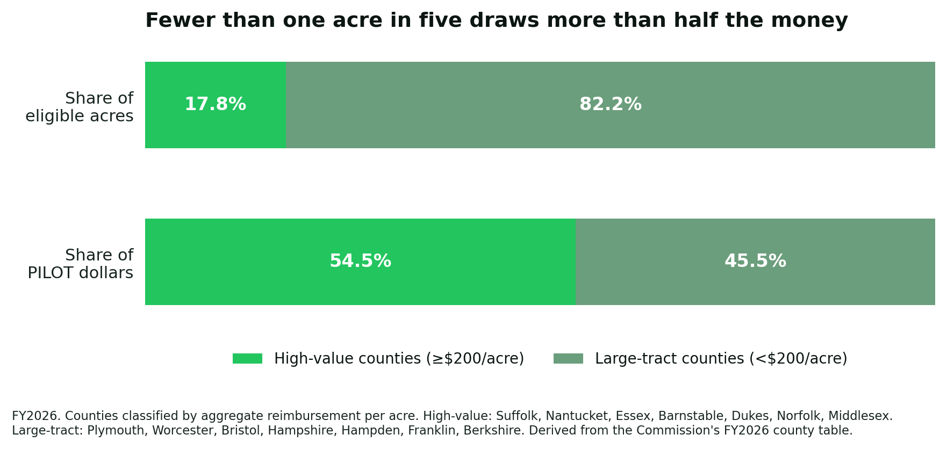
Figure 1. Share of eligible acres against share of PILOT dollars, by land class.
Fewer than one acre in five draws more than half the money.
This is the disparity host communities actually experience, and stating it as a land-class problem rather than a regional one matters for two reasons. It is more accurate — Plymouth and Worcester sit on the large-tract side of the line, and Dukes and Nantucket on the high-value side, so this is not a map of east against west. And it identifies the design defect rather than the political geography: the Commonwealth applies a single value-proportional rate to a portfolio containing both urban parcels and twenty-thousand-acre forests.
Value-proportionality is defensible for the first. For the second it measures the wrong thing entirely, because a forest's burden on its host town — road frontage, drainage structures, emergency response, wildfire exposure — has almost no relationship to its assessed value.
Every comparison state has reached the same conclusion and acted on it. Minnesota sets a flat $3.087 per acre for tax-forfeited and other DNR land and the greater of $5.281 per acre or 0.75% of appraised value for acquired natural resources land. Wisconsin pays the greater of a local-tax-rate calculation or $3.50 per acre. Michigan pays $4.00 per acre indexed. Pennsylvania pays $7.20 per acre.
Massachusetts is the outlier not in what it pays but in refusing to classify what it owns.

2. Share erosion is automatic, directional, and permanent.
Because the appropriation is fixed before the distribution runs, the program is zero-sum by construction. One municipality's gain in share is another's loss. A town whose eligible land value rises 4% in a year when statewide value rises 6% receives less money than the year before, despite its own land having appreciated. Nothing in that outcome reflects a judgment that the town needs less. It is arithmetic.
The framework re-indexes every municipality's base value to its Equalized Valuation on a two-year cycle. Land values in the eastern half of the Commonwealth have grown faster than in the west for the entire life of the current system — the Commission's own valuation maps make the point in two slides. Faster eastern appreciation therefore transfers share eastward at every reset. The transfer requires no vote, appears in no line item, and is invisible in year-over-year payment figures because the appropriation has grown fast enough to mask it.
The Commission's appendix demonstrates the mechanic. Between FY2017 and FY2026, Pittsfield's payment rose 61.9% and Greenfield's 70.5%, while Holyoke's rose 176.0%. All three gained dollars. Only one gained share. In a fixed-pool program, only share is real.

3. Article 97 does double duty.
Article 97 requires a two-thirds roll-call vote of both legislative branches to dispose of or change the use of conservation land, reinforced by the 2022 Public Lands Preservation Act's no-net-loss requirement (M.G.L. c.3 §5A). It is a strong and, in this paper's view, worth-keeping protection.
It also produces a consequence nobody designed. Article 97 land is untaxable, so the host town depends on PILOT. Article 97 land is also excluded from State Land for Homes, so the host town cannot convert any of it to taxable housing. The town gets the fiscal burden of hosting and access to neither remedy.
The exclusion is not incidental. The §122 surplus-land guidance states that all state-owned land not subject to Article 97 is eligible to be declared surplus, and the June 2025 inventory release confirms the review exempted protected open space, wetlands, and flood plains outright.
The result is a program that distributes housing-development opportunity in inverse proportion to conservation-land hosting. This is worth stating precisely because it is not a criticism of State Land for Homes, which is doing what it was designed to do. It is an observation that the design leaves out exactly the communities this Commission was convened to examine.

Part II — What the money actually looks like

The distribution
County | Acres (FY26) | PILOT (FY26) | Aggregate $/acre | As published | Share of acres | Share of dollars
Suffolk | 178 | $1,004,212 | $5,642 | $4,885 | 0.0% | 1.8%
Nantucket | 89 | $342,747 | $3,851 | $3,862 | 0.0% | 0.6%
Dukes | 5,462 | $4,729,800 | $866 | $1,394 | 1.2% | 8.7%
Norfolk | 9,897 | $4,145,898 | $419 | $285 | 2.1% | 7.6%
Middlesex | 23,546 | $8,729,394 | $371 | $722 | 5.1% | 16.0%
Essex | 17,109 | $5,408,750 | $316 | $3,105 | 3.7% | 9.9%
Barnstable | 26,477 | $5,358,642 | $202 | $1,879 | 5.7% | 9.8%
Bristol | 19,428 | $3,766,930 | $194 | $272 | 4.2% | 6.9%
Plymouth | 32,234 | $4,277,570 | $133 | $1,062 | 6.9% | 7.8%
Worcester | 72,440 | $6,441,593 | $89 | $280 | 15.6% | 11.8%
Hampshire | 33,619 | $2,129,145 | $63 | $110 | 7.2% | 3.9%
Hampden | 23,787 | $1,447,908 | $61 | $89 | 5.1% | 2.7%
Berkshire | 135,417 | $4,597,030 | $34 | $47 | 29.2% | 8.4%
Franklin | 64,502 | $2,128,653 | $33 | $59 | 13.9% | 3.9%
Statewide | 464,184 | $54,508,272 | $117 | $775

Four western counties — Berkshire, Franklin, Hampshire, Hampden — hold 55.4% of eligible acres and receive 18.9% of dollars. Four eastern counties — Suffolk, Norfolk, Middlesex, Essex — hold 10.9% of acres and receive 35.4%.
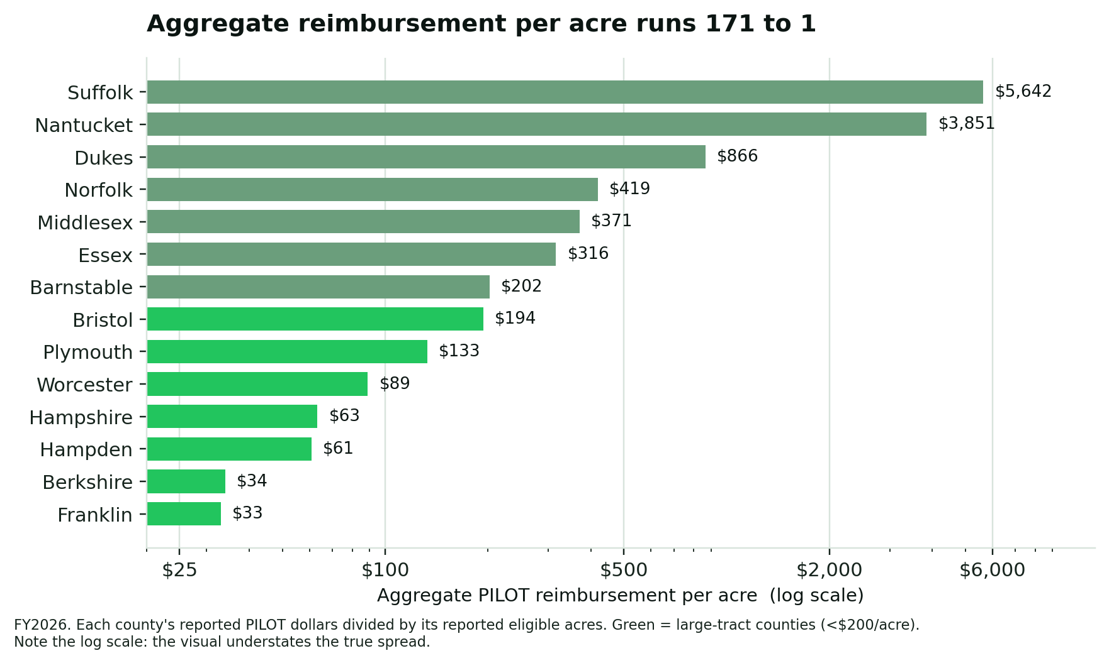
Figure 2. Aggregate reimbursement per acre by county, FY2026.
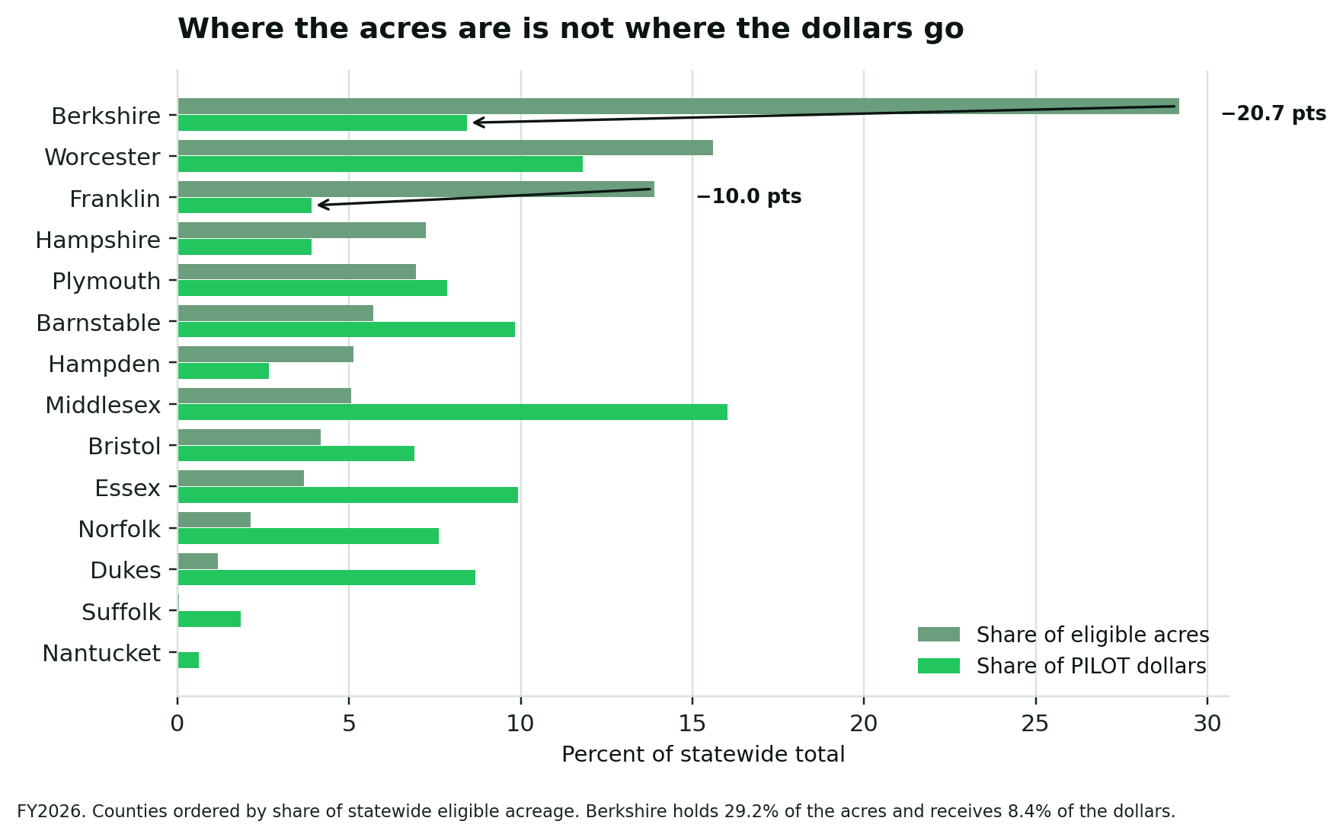
Figure 3. Share of statewide eligible acres against share of statewide PILOT dollars, by county.

A note on the Commission's published statistic
The listening-session materials report per-acre reimbursement in a column labeled Average of Actual PILOT Per-Acre, characterizing the range as $47/acre in Berkshire County to $4,885 in Suffolk.
Those figures cannot be aggregate ratios. Dividing each county's own reported dollars by its own reported acres — both from the same table — produces materially different values, shown above. The published column appears to be an unweighted mean of municipal per-acre values within each county, a construction that weights a two-acre host equally with a twenty-thousand-acre host and systematically overstates reimbursement in counties containing small-acreage, high-value municipalities. The Essex divergence is tenfold: $3,105 as published, $316 in aggregate.
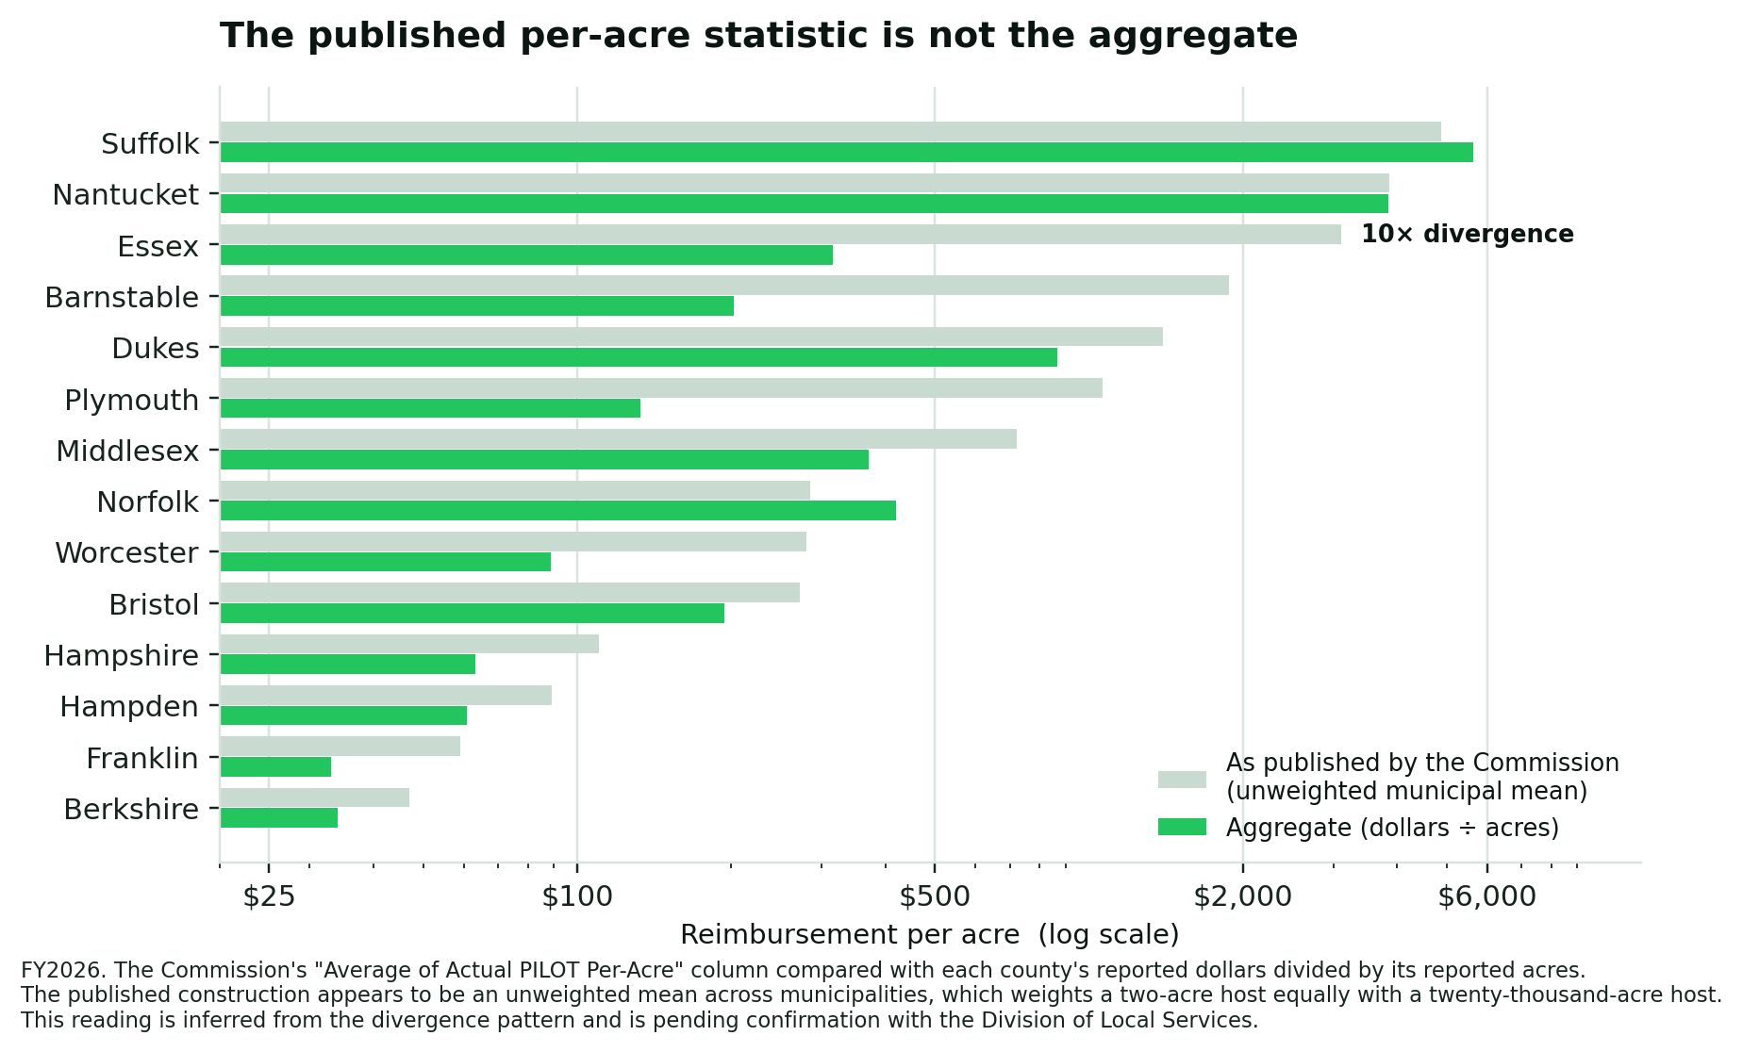
Figure 4. The Commission's published per-acre column compared with each county's aggregate ratio.
Measured on aggregates, the reimbursement spread is 171 to 1 (Suffolk to Franklin), not the roughly 104 to 1 the published range implies.
We should be plain about the limits of this observation. What is certain is the arithmetic: dividing the Commission's own reported dollars by its own reported acres produces the aggregate column above, and those values differ materially from the published ones. That computation is reproducible from the Commission's table and does not depend on any assumption of ours.
What is inferred is the explanation. We read the published column as an unweighted mean across municipalities because that construction would produce exactly this divergence pattern. We have not seen documentation of the calculation, and we have not asked the Division of Local Services to confirm it. If DLS computes the figure by some other method, our characterization is wrong and we will correct it — the underlying disparity finding would be unaffected, because it rests on the aggregates rather than on the published column.
This is a methodology observation, not an allegation. The underlying data are internally consistent; our concern is only that the summary statistic, however it is built, understates the disparity it exists to describe.

What Massachusetts is not
Two claims should be retired before the Commission's deliberations proceed.
Massachusetts is not underfunding the program in aggregate. DOR's own local-rate estimate implies a shortfall of $4.5–5.5 million, or 8–10%.
Massachusetts is not ungenerous by national standards — but the right comparison is like-for-like. The blended $117/acre is not a meaningful cross-state number, because it averages land classes the comparison states price separately. Measured against comparable land, Berkshire's $34/acre still exceeds Minnesota's $5.281 acquired-natural-resources floor by roughly six times, and Massachusetts pays more per acre than New York's Adirondack towns receive.
The Commonwealth's problem is not the level. It is that a single value-proportional rate is applied to a portfolio containing both urban parcels and large undeveloped tracts, that payments depend on an annual appropriation, and that concentration is nowhere recognized.

Part III — Track A: Fixing the formula
Track A is worth doing. It is also bounded, zero-sum, and — on the cross-state evidence — the track most likely to produce a formula that looks corrected without being funded.

A1. Publish the aggregate statistic. (No cost. No legislation.)
Report per-acre reimbursement as county and municipal aggregates, alongside share-of-acres against share-of-dollars, and retire the unweighted mean. This is the highest-leverage item available to the Commission because every subsequent argument runs through the number.

A2. Fund to the Department of Revenue's own local-rate estimate.
Cost: $4.5–5.5 million above FY2026. Closes the aggregate gap entirely.
Objection, which we think is correct: this does nothing about distribution. It is the cheapest lever and the least corrective, and adopting it alone would let the Commission report progress without addressing the finding that convened it.

A3. Classify the portfolio before adjusting the rate.
The single change with the largest structural effect is also the one no Massachusetts reform has attempted: stop applying one value-proportional rate to every acre the Commonwealth owns.
Every comparison state distinguishes land classes and sets a different basis for each. Minnesota pays a flat $3.087 per acre for tax-forfeited and other DNR land and the greater of $5.281 per acre or 0.75% of appraised value for acquired natural resources land. Wisconsin §70.114 pays the greater of a local-tax-rate calculation or $3.50 per acre. Michigan pays $4.00 per acre indexed. Pennsylvania pays $7.20 per acre across DCNR, Fish & Boat, and Game Commission holdings.
The "greater of" construction is the important one, because it does exactly what the Massachusetts formula cannot: it preserves value-proportionality where value is the right measure, and installs a per-acre floor where it isn't. A developed urban parcel clears the floor on value alone. A twenty-thousand-acre forest does not, and receives the floor instead.
Objection: a per-acre floor is not, strictly, a payment in lieu of taxes — it compensates burden rather than foregone revenue. That objection is correct on the merits and should be met by naming the component honestly rather than folding it into the value formula and hoping the distinction goes unnoticed.

A4. Adopt a concentration adjustment — but not at Minnesota's rate.
Minnesota is the only state to have squarely legislated the concentration problem before this Commission. Its 2023 reform (H.F. 825 / 2023 Ch. 64) added per-acre supplements keyed to the share of a county's total area in PILT-eligible ownership: +$0.185/acre where that share is 25% or more, +$0.082/acre where 10–25%. Minnesota also codified an express statutory purpose — addressing "the disproportionate impact of state land ownership" — at Minn. Stat. §477A.10.
The principle is exactly right. The magnitude is not.
Those supplements total roughly $1.36 million against a $48.8 million program — 2.8%. Applied at Minnesota's rate to Berkshire County's 135,417 acres, the supplement would yield $25,052 per year. Minnesota identified that six counties hold 62% of its PILT acres while receiving 39% of payments, then corrected it with a payment that moves under three percent of the program.
The Commission should take Minnesota's principle and reject its scale. A statutory equity-purpose clause modeled on §477A.10, paired with a concentration supplement set at a magnitude that actually closes the gap it names.

A5. Put the hold-harmless in statute.
The Commonwealth has been appropriating to avoid year-over-year decreases without being required to. Municipalities cannot budget against a practice. Vermont's PILOT statute (32 V.S.A. §3708) contains a floor guaranteeing no municipality falls below its historical payment; Massachusetts's own Watershed PILOT already carries a statutory hold-harmless.
Objection: it constrains appropriation flexibility. That is the point, and it is a trade the Legislature has already made for the Commonwealth's other PILOT program.

A6. Rationalize eligibility.
Approximately 245,000 acres — 34.7% of the Commonwealth's 706,000 state-owned acres — generate no payment. The Commission's own materials conclude that current eligibility "reflects historical decisions rather than intentional policy design." The tax-status-at-acquisition test and the holding-agency test both fail the question of whether identical parcels are treated identically.
Objection: the cost is unquantified, and bringing ineligible acreage into the base without a corresponding appropriation increase would dilute every current recipient's share — the precise hazard this paper documents. Pricing and phase-in are prerequisites, not details.

A7. The lesson Track A must not ignore
Two states prove that formula design without funding architecture is decorative.
Connecticut enacted a genuinely sophisticated tiered PILOT in 2021 (P.A. 21-3), keyed to Equalized Net Grand List Per Capita, with a Tier 1 trigger for municipalities where the state owns more than 50% of the property. Full implementation was scored at roughly $137 million per year in additional cost. It has never been funded to the statutory formula; when the appropriation is insufficient, grants are prorated.
Michigan wrote "payment in full" into statute in 2012 (PA 603/604). House Fiscal Agency materials confirm appropriations have repeatedly been prorated below statutory levels, and that prorated payments satisfy the obligation — the appropriations act overrides the entitlement language.
For scale: Connecticut's unfunded formula gap alone is about 2.5 times the entire Massachusetts SOL PILOT program.
The structural alternatives that do work are visible in the same evidence. Pennsylvania funds its per-acre payments from dedicated gaming revenue (Act 34 of 2023 raised DCNR land from $6.00 to $7.20/acre and Fish & Boat and Game Commission land from $3.60 to $7.20/acre, split three ways among county, municipality, and school district). Federal PILT became a mandatory entitlement in 2014 and reached $733.0 million in FY2026 — though that mandatory status expires after FY2026 and reverts to discretionary absent action, which is its own cautionary note. Minnesota pays from an open, non-capped General Fund appropriation.
If the Commission recommends a concentration fix delivered through a capped annual appropriation, it should expect Connecticut's result.

Part IV — Track B: Growing the base
Track A argues about how to divide $54.5 million. Track B asks a different question: how does a town with 30% of its land area in state ownership ever grow its own tax base?

The mechanism, and why it is structurally superior
Under Proposition 2½, new growth is added permanently to a municipality's levy limit. It is capacity the town may levy without an override, on top of the annual 2.5% and any override, and it compounds into the base as units come online.
A PILOT dollar is an annual appropriation subject to the politics of the next budget cycle. A new-growth dollar is permanent taxing capacity the town owns outright.
This is not a marginal difference. One acre converted from untaxed state land to taxable housing is worth structurally more to a host municipality than the equivalent PILOT increase, forever — and it takes nothing from any other community.
It also breaks the circular trap that afflicts rural Massachusetts: infrastructure cannot be funded without new growth, and new growth cannot happen without infrastructure. Edge parcels adjacent to existing roads break the circle at exactly the point where the infrastructure already exists.

The proposal: screened edge release
The Commonwealth holds hundreds of thousands of conservation acres. Some fraction of the perimeter of that holding is already-disturbed land — old field edges, former landings, roadside strips, previously developed parcels acquired as part of larger tracts — fronting on existing town roads. Releasing a screened portion of that edge for housing would convert untaxed acreage into permanent local tax base, produce housing in the communities least able to zone their way to it, and cost the Commonwealth nothing.
The framing that matters: edge release should fund core consolidation.
This is not a proposal to trade conservation for housing. It is a proposal to trade low-value perimeter for high-value core, using mechanisms other states have already built:
- New York's equal-or-greater-value land swap model. Because Article XIV forbids sale, lease, or exchange of Forest Preserve outright, New York has amended its constitution roughly sixteen times via parcel-specific, voter-ratified swaps — Perkins Clearing (~8,500 acres), Keene (12 acres out, 144 in), Raquette Lake (1 out, 12 in). Every one ran net-additive to conservation.
- Maine's same-region replacement mandate (Art. IX §23), which pairs a two-thirds vote with a same-county, same-purpose replacement-land requirement.
- New Jersey's Green Acres no-net-loss diversion regime, requiring State House Commission approval, an ecological-impact test, and replacement land of equal or greater value.
- Massachusetts's own Public Lands Preservation Act (M.G.L. c.3 §5A), which already codifies no-net-loss for Article 97 dispositions.
The screening framework is likewise already built and currently unused for this purpose. BioMap — the Natural Heritage and Endangered Species Program's joint product with The Nature Conservancy, updated 2022 — maps Core Habitat (~1.24 million acres) and Critical Natural Landscape with connectivity modeling. It is non-regulatory and is not linked to any disposal pathway. Priority Habitat under the Massachusetts Endangered Species Act supplies the separate regulatory screen.
For edge-depth thresholds, the Environmental Law Institute's Conservation Thresholds for Land Use Planners (2003), synthesizing more than 1,400 studies, recommends buffer zones of 230 to 300 meters from habitat edges to mitigate edge effects, maintaining habitat patches larger than 55 hectares, and conserving 20–50% of the total landscape.
A defensible framework therefore looks like: protect all BioMap Core Habitat and Critical Natural Landscape, plus a 230–300 m buffer; consider for release only already-disturbed parcels outside that envelope, fronting existing public roads; screen out wetlands, priority habitat, steep slope, and connectivity corridors; route every disposition through the existing Article 97 two-thirds vote and PLPA no-net-loss test; and direct proceeds and swaps to core consolidation.
No state has assembled this. The building blocks exist separately in New York, Maine, New Jersey, Florida, and Massachusetts. No jurisdiction has combined constitutional protection, ecological core/edge screening, and edge-release-for-housing into a single pathway. Massachusetts can be first.

The objection the Commission will hear, and the answer
The Department of Conservation and Recreation and the conservation members of this Commission will say — correctly — that intact forest is the cheapest stormwater and climate infrastructure a municipality has, that edge development is where fragmentation harm concentrates, and that a release program creates a precedent that will be widened by future legislatures.
Three responses, offered honestly:
First, the screening framework above is designed so that no core tract is touched and the buffer thresholds come from the conservation literature, not from a development proponent.
Second, the swap structure means the program is net-additive to conservation on the New York model, not a trade against it. If it cannot be run net-additive, it should not be run.
Third — and this is the argument the Commission should weigh most carefully — the Commonwealth's conservation and biodiversity targets are currently being financed disproportionately by a small number of rural tax bases that were never asked. A program that permanently removes parcels from both the tax base and the development base, and compensates at $34 an acre, is not a stable long-term basis for public support of conservation in the communities that host it. Edge release, done right, is a conservation-durability measure.
We state plainly that this is a contested judgment, not a finding. The Commission should hear DCR's version of it directly.

B2. A municipal fiscal impact statement at acquisition
Before the Commonwealth acquires land, disclose the permanent effect on the host municipality's tax base and PILOT position.
Objection: friction in acquisition at a moment when climate and biodiversity targets require speed. Counter: the current practice asks host communities to absorb a permanent fiscal consequence without ever quantifying it for them.

Part V — What other states actually do
Scope and vintage note: the survey underlying this section verified nine programs against current (2024–2026) primary sources — New York, Minnesota, Michigan, Wisconsin, Pennsylvania, Connecticut, Vermont, Maine, and federal PILT — not fifty. A comprehensive fifty-state inventory does not currently exist in verified form; the most complete prior survey is a 1996 New York Department of Taxation and Finance study built on 1990 and 1994 data, which found programs in 34 states and none in roughly 16. Approximately 28 states could not be re-verified against current primary sources. Those states are reported in Appendix B as unverified, not as confirmed current entries. We consider a stale confident table more damaging than an honest incomplete one.

The four mechanisms
Full local taxability. New York taxes designated state land "for all purposes" under RPTL §532, assessed by the local assessor as if privately owned, with the state holding only the appeal rights of any taxpayer. The Town of Shandaken line of cases confirmed the obligation. Roughly 3.9 million acres are taxable, plus easements on 800,000+ acres. The state's all-in liability was about $250 million in FY2016 — up from roughly $100 million twenty years earlier.
Per-acre payment. Minnesota, Michigan, Pennsylvania, Wisconsin, Vermont. Rates are low in absolute terms (Minnesota's aggregate is $5.71/acre; Pennsylvania's is $7.20; Michigan's swamp and tax-reverted rate is $4.00 indexed) but they are entitlements, not shares of a pool.
"Greater of" hybrids. Minnesota pays the greater of $5.281/acre or 0.75% of appraised value on acquired natural resources land. Wisconsin §70.114 is the closest analogue to what Massachusetts municipalities have asked for: for land acquired after 1991, the payment is the greater of the parcel's estimated value times the aggregate local net general property tax rate, or $3.50/acre.
Share-of-appropriation. Massachusetts SOL PILOT. Connecticut's tiered system is a variant.

The lesson that matters most
Local assessment authority, not the nominal rate, is what protects host communities.
New York's executive branch attempted three separate times — under Governors Pataki, Paterson, and Cuomo — to convert full taxability into a capped PILOT. The best-documented attempt is Cuomo's 2018–19 Executive Budget, Article VII Part F, which would have frozen Forest Preserve assessments, replaced locally-assessed taxation with PILOTs at a rate set by the State Comptroller, and capped growth by a state-determined factor.
A coalition of local governments, school districts, and conservation organizations defeated it. Their arguments: it broke the 1885–86 bargain; central rate-setting would erode payments in real terms and shift burden onto private landowners in Forest Preserve towns; and the Budget Division had not analyzed local impacts.
All three attempts failed. Full taxability survives. In every case the fight was over who assesses and whether payments can decline — not over the rate.
Massachusetts currently sits on the losing side of both questions. The Bureau of Local Assessment values state-owned land centrally, and payments can decline because share can erode.

Migration in the other direction
New York's Putnam County is the one documented case of a jurisdiction moving from a formula PILOT to full taxability. Putnam had the highest percentage of land in exempt state ownership (8.4%) and little taxable state land; the state instituted a formula PILOT ($400,000 in 1994, raised to $600,000 in 1995). In 2004, Chapter 364 amended RPTL §532(d) to make Putnam state land directly taxable for all purposes.
New York also operates concentration triggers Massachusetts lacks entirely. RPTL §534(3) makes certain reforestation lands taxable only where they exceed 3,000 acres and comprise at least 9.5% of the assessing unit's acreage — a dual absolute-and-proportional test directly applicable to the Massachusetts problem.

Part VI — The analysis that has not been run
Every claim in Part IV about edge acreage is conceptual. Parcenomics has published that limitation before — our April 2026 housing brief flagged the state forest edge opportunity as "conceptual pending DCR GIS analysis of parcel suitability, infrastructure proximity, and ecological sensitivity" — and it remains true.
We recommend the Commission direct that this analysis be conducted, and we specify it here so that it can be.

Specification
Inputs. MassGIS DCR and Division of Fisheries and Wildlife ownership layers; MassGIS road centerline file; BioMap Core Habitat and Critical Natural Landscape; MassDEP wetlands; NHESP Priority Habitat; slope derived from statewide elevation data; municipal assessor parcel boundaries.
Method. Intersect state ownership against road centerlines. Buffer to a defensible edge depth from the road, tested at multiple depths. Subtract the full BioMap Core Habitat and Critical Natural Landscape envelope plus a 230–300 m ecological buffer. Subtract wetlands, Priority Habitat, and slope above a buildability threshold. Classify the residual by existing disturbance. Aggregate to the municipality.
Outputs. Developable edge acreage by municipality; estimated unit yield at stated density assumptions; and permanent new-growth levy capacity at stated assessed-value assumptions, presented as a band with every modeling assumption labeled.
Verification discipline. Measured quantities — acreage, slope, distance — reported as measured. Modeled quantities — unit yield, assessed value, absorption pace — reported as labeled scenario bands, never as point estimates.

Why this specification is credible
This is the same structure Parcenomics has already published in municipal work.
In the Great Barrington fiscal levers report, we measured the town's impervious cover directly from the MassGIS 2016 Land Cover / Land Use data: 44.45 million ft² total (~1,020 acres), 15.2 million ft² of road right-of-way excluded, 29.2 million ft² billable = 8,883 Equivalent Residential Units, with the tax-exempt share of the billable base at 16.9% — the basis for a stormwater utility fee that reaches parcels the property tax cannot. The revenue requirement was published as a band ($200K–$620K), not a point estimate, because the town does not engineer-cost its drainage program.
The same report's new-growth analysis converts units to permanent levy capacity at labeled value assumptions ($500K / $700K / $800K per home), bracketed for sensitivity, with the underlying rate verified and the value assumptions explicitly flagged as modeled.
Edge inventory is the same operation against different layers: ownership and roads in place of land cover, ecological screens in place of right-of-way exclusions, and the same measured-quantity-plus-banded-scenario discipline throughout.

Part VII — Answering the Commission's questions
Does the current PILOT program work as intended? It works exactly as designed. The design compensates land value and nothing else. Whether that was the intent is the question the Commission should put to the record.
How does the program affect municipalities across the Commonwealth? Asymmetrically and directionally. 55.4% of eligible acres sit in four western counties receiving 18.9% of the dollars, and the gap widens on its own at every valuation cycle.
Are there opportunities to improve how the program operates? Yes, and the least expensive costs nothing: publish the aggregate per-acre and share-based statistics so the distributional question is visible in the Commission's own materials.
What tradeoffs should be considered? The central one is not fiscal. Closing the aggregate gap costs $4.5–5.5 million. The real trade is between the Commonwealth's budget flexibility and municipalities' ability to plan — the same trade already made, in the other direction, for Watershed PILOT. The second is between the speed of conservation acquisition and the fiscal durability of the communities hosting it.
Does the program appropriately balance conservation, biodiversity, and climate goals? The program is currently structured so that the more successfully the Commonwealth conserves land in a low-value county, the less that county is compensated per acre for hosting it — while Article 97 simultaneously excludes it from the state's principal land-for-housing program. Whatever balance that represents, it was not chosen. A screened edge-release program directing proceeds to core consolidation would improve conservation outcomes and host-community fiscal capacity at the same time, and is the recommendation this paper most urges the Commission to examine.

Appendix A — Verification register
VERIFIED — stated directly in the Commission's July 2026 listening-session materials:
FY26 SOL PILOT total $54,508,272 · FY26 Watershed PILOT $9,312,874 · county acreage and payment table · 464,184 eligible acres · ~461,000 eligible of ~706,000 state-owned acres · Athol worked example · DOR local-rate estimate $59–60 million · FY26 local aid $8,139,530,607 · 16 of 29 Watershed communities receiving hold-harmless (~$1 million) · town payment series for Marion, Greenfield, Holyoke, Pittsfield FY17–FY26 · SOL and Watershed formula statements · MGL c.58 §§13–17 · 2016 Municipal Modernization Law.
VERIFIED — external primary sources:
Minnesota per-acre rates and concentration supplements (Minn. Stat. §477A.10–.14; H.F. 825 / 2023 Ch. 64; MN DNR PILT Overview 2025: $48,836,442 across 8,559,263 acres) · New York RPTL §532, §534(3) (NY DTF Pub. 1212, Jan. 2019; ~$250M FY2016 all-in) · Connecticut P.A. 21-3 tier structure (CT OPM) · Michigan MCL 324.2150 and proration practice (MI House Fiscal Agency) · Pennsylvania Act 34 of 2023 rates · Wisconsin Wis. Stat. §70.113/.114/.119 · Vermont 32 V.S.A. §3708 · Federal PILT FY2026 $733,591,949 (DOI PILT National Summary) · Massachusetts Affordable Homes Act §122 surplus land guidance (Article 97 exclusion) · State Land for Homes inventory and unit counts · BioMap Core Habitat ~1.24 million acres · ELI Conservation Thresholds for Land Use Planners (2003) buffer recommendations.
DERIVED — computed from the above (script: `pilot_calc.py`):
Aggregate per-acre by county · statewide $117.43/acre (blended; not a valid cross-state comparator) · uniform rate $10.33 per $1,000 · land-class split: high-value 7 counties 82,758 ac / 17.8% of acres / $29,719,443 / 54.5% of dollars / $359 per acre; large-tract 7 counties 381,427 ac / 82.2% / $24,788,829 / 45.5% / $65 per acre · western four-county 55.4% / 18.9% · eastern four-county 10.9% / 35.4% · Suffolk:Franklin 171:1 · aggregate shortfall $4.49–5.49M (8.2–10.1%) · 245,000 ineligible acres (34.7%) · town growth rates FY17–FY26 · Minnesota aggregate $5.71/acre · Berkshire $33.95/acre against Minnesota's $5.281 acquired-land floor = 6.4:1 (like-for-like) · MN supplements as 2.8% of program · MN supplement rate applied to Berkshire = $25,052 · CT unfunded gap as 2.5× the MA program.
Note on the land-class split: the $200/acre boundary is an analyst-chosen cut, not a statutory category. It is used to demonstrate that the program's dollars concentrate on a small share of high-value acreage; the finding is robust to reasonable alternative thresholds, but the specific counties on each side of the line depend on where the line is drawn.
UNVERIFIED — must not enter prose without a source:
- Municipal service costs attributable to hosting state-owned land. No figure appears in this paper. The single most important missing number in the debate.
- Developable edge acreage. No figure appears in this paper pending the Part VI analysis.
- The construction of the Commission's Average of Actual PILOT Per-Acre column. Our reading is inferred from the divergence pattern and is disclosed as such in Part II. Not resolved; see Appendix C.
- FY16–FY25 appropriation levels — readable only from the deck's bar chart, and used nowhere numerically in this paper.
- Whether the appendix town series (Marion, Greenfield, Holyoke, Pittsfield) are SOL PILOT only or include other components. Used illustratively in Part I; the share-erosion mechanic does not depend on them. Not resolved; see Appendix C.
- Approximately 28 states' current program status (see Appendix B).
Arithmetic note: county acreage sums to 464,185 against a stated grand total of 464,184. One-acre rounding in the source.

Appendix B — Comparative survey scope and limitations
What was verified. Nine programs were verified against current (2024–2026) primary sources: New York, Minnesota, Michigan, Wisconsin, Pennsylvania, Connecticut, Vermont, Maine, and federal PILT. Every comparative claim in Part V rests on one of these.
What was not. Approximately 28 states could not be re-verified within the scope of this paper and are not characterized in it. They are not asserted to lack programs; their current status is simply unconfirmed.
Why the existing national inventory cannot be used. The most complete prior survey is the September 1996 New York Department of Taxation and Finance study, itself built on 1990 (Adams) and 1994 (Fong & Kuenzi) data. It found reimbursement programs in 34 states and none in roughly 16. That baseline is now three decades old and demonstrably decayed. Three concentration mechanisms it recorded — Illinois compensating school districts where the state owned more than 45% of district land, Colorado triggering at 0.1% of county area, Georgia at 20,000 acres — could not be confirmed against current code. In the Illinois case no current authorizing statute could be located at all, which suggests the provision has been repealed. These are cited in this paper only as historical, never as current practice.
Why we did not publish a fifty-row table anyway. A comparative matrix is only useful to this Commission if a member can check their own state and find it right. One stale row discredits the rest. Nine verified programs supporting a structural argument is more defensible than fifty rows of mixed vintage supporting a broader one.
Source basis. The comparative research underlying Parts III and V was conducted across two structured research passes and cites more than 40 primary and secondary sources — state statutes and session laws, legislative fiscal notes, state revenue and natural-resources agency publications, legislative auditor reports, Congressional Research Service analysis, and federal Department of the Interior program summaries. Every source is named at the point of use.

Appendix C — Open issues
This paper is deliberately bounded. The following questions bear directly on the Commission's mandate, are not answered here, and are not answerable from the public record as it currently stands. Each is a defined piece of work rather than an unknown.
1. Municipal service costs attributable to hosting state-owned land.
The formula excludes service costs by design, and no one has measured them. Road miles maintained to reach and border state holdings, road-stream crossings and drainage structures carrying water off them, emergency medical and fire response, search and rescue, wildfire and invasive-species management at the edges — all scale with area, none appear in the calculation. Until this is quantified for a representative sample of host communities, any claim that the current payment is adequate or inadequate is an assertion rather than a finding. Scope: a service-cost study across a stratified sample of high-concentration host municipalities.
2. Developable edge acreage.
Part IV's argument is structurally sound and quantitatively empty. The specification in Part VI is complete and runnable, but the analysis has not been performed, and this paper publishes no acreage, unit, or revenue figure derived from it. Scope: the GIS run specified in Part VI, statewide or by region.
3. Current program status in approximately 28 states.
See Appendix B. The 1996 baseline has decayed past the point of safe use. Scope: a fifty-state statutory verification producing a vintage-labeled matrix.
4. The construction of the Commission's published per-acre statistic.
Part II demonstrates that the Average of Actual PILOT Per-Acre column cannot be an aggregate ratio, and infers from the divergence pattern that it is an unweighted municipal mean. That inference has not been confirmed with the Division of Local Services, and we publish it as an inference rather than a finding. If DLS supplies the actual construction, we will update this paper to reflect it. The disparity finding itself rests on aggregates computed from the Commission's own table and is unaffected either way. Scope: one confirmation from DLS.
5. The composition of the town-level payment series.
The Commission's appendix reports FY17–FY26 series for Marion, Greenfield, Holyoke, and Pittsfield. Whether these are SOL PILOT only or include other components is not stated. Part I uses them to illustrate share erosion; the mechanic itself follows from the formula and does not depend on these four towns. If the series are composite, the illustration would be replaced, not the argument. Scope: one confirmation from DLS.
6. The cost of eligibility rationalization.
Approximately 245,000 state-owned acres generate no payment. Bringing them into the base without a corresponding appropriation increase would dilute every current recipient's share. The cost of doing it properly has not been priced. Scope: a fiscal estimate under alternative phase-in schedules.
7. Whether a Massachusetts concentration supplement can be keyed to municipal land-area share.
Minnesota's trigger is the percentage of county area in state ownership. Massachusetts distributes to municipalities, and the municipal land-area denominators required to replicate that trigger were not assembled for this paper. Scope: municipal land-area compilation and supplement modeling at alternative thresholds and rates.

Parcenomics prepared this paper independently and at its own cost as a contribution to the Commission's public record. The open issues above are stated as they are so that anyone — the Commission, a regional planning agency, or an individual municipality — can commission the work from any competent analyst. Parcenomics is available to scope or perform any of it.

About this paper
Locked Twice: Article 97, the PILOT formula, and the two things it keeps rural Massachusetts from doing
Prepared and submitted for the record of the Governor's PILOT Commission, established by Executive Order 645.
Patrick White
Principal Researcher, Parcenomics
[www.parcenomics.com](https://www.parcenomics.com)
patrickwhitestockbridge@gmail.com · 413-441-5231
Parcenomics provides municipal fiscal analytics for Massachusetts cities and towns — rate classification, compliance review, assessment equity, exemption analysis, and municipal fiscal profiles. Every finding is traced to the public record.
This paper was prepared independently and at Parcenomics' own cost as a contribution to the Commission's public record. It was not commissioned by, and does not represent the position of, any municipality, agency, or organization.
Parcenomics · aggregate · assimilate · evaluate
Every figure traces to the public record; interpretation and any decisions rest with the reader.
© 2026 Patrick White.
This paper is free to quote, excerpt, and reproduce in full with attribution — in the Commission's public record, in municipal board packets, in regional planning materials, and in press coverage. No permission request is necessary. Please attribute to Patrick White, Parcenomics, and link to www.parcenomics.com where the format allows.

